C01
ASSESSMENT TOOL 3
NAME: G. Venkatesh Reddy
REGISTRATION NUMBER:192372262
COURSE NAME: INTERNET PROGRAMMING
COURSE CODE: CSA4308

Scenario: Web Development Standards Implementation
A startup is developing a modern web application. During development, the team encounters
multiple issues related to HTML elements, HTTP methods, XML syntax, and web
communication protocols.
The following observations are made:
● The team needs to embed a promotional video on the homepage.
● A registration form must securely send user data to the server.
● The navigation menu must follow semantic HTML standards.
● XML configuration files are being used but contain syntax errors.
● The application must communicate over the correct web protocol.
Data Snippets Provided
Snippet 1: Video Embedding Options
A. &lt;media src=&quot;video.mp4&quot;&gt;&lt;/media&gt;
B. &lt;video src=&quot;video.mp4&quot; controls&gt;&lt;/video&gt;
C. &lt;movie src=&quot;video.mp4&quot;&gt;&lt;/movie&gt;
D. &lt;vid src=&quot;video.mp4&quot;&gt;&lt;/vid&gt;
Snippet 2: Form Submission Methods
A. GET
B. POST

C. PUT
D. DELETE
Snippet 3: Navigation Elements
A. &lt;div&gt;
B. &lt;nav&gt;
C. &lt;section&gt;
D. &lt;header&gt;
Snippet 4: XML Syntax
A. &lt;note&gt;&lt;to&gt;User&lt;/to&gt;&lt;from&gt;Admin&lt;/from&gt;
B. &lt;note&gt;&lt;to&gt;User&lt;/to&gt;&lt;from&gt;Admin&lt;/from&gt;&lt;/note&gt;
C. &lt;note&gt;&lt;to&gt;User&lt;/from&gt;&lt;/note&gt;
D. &lt;note to=&quot;User&quot;&gt;&lt;/note
Snippet 5: Web Communication Protocols
A. FTP
B. HTTP
C. SMTP
D. SNMP
Questions:
1. Select the correct HTML tag for video embedding and justify your answer.
2. Identify the appropriate HTTP method for form submission and explain why.
3. Choose the proper semantic element for navigation and justify its usage.
4. Identify the correct XML syntax and explain the error in other options.
5. Choose the correct protocol for web communication and justify your choice.

Scenario: Web Development Standards Implementation
A startup is developing a modern web application. During the development process, the team faces various issues related to HTML elements, HTTP methods, XML syntax, and web communication protocols. The correct standards must be followed to ensure that the application is functional, secure, accessible, and easy to maintain.

1. Select the correct HTML tag for video embedding and justify your answer.
Correct Answer: B. <video src="video.mp4" controls></video>
The correct HTML element for embedding a video in a web page is the <video> element.
The correct code is:
<video src="video.mp4" controls></video>
The HTML5 <video> element is specifically designed to embed video content directly into a web page without requiring additional browser plugins. The src attribute specifies the location or path of the video file. In this example, the video file is named video.mp4.
The controls attribute tells the browser to display built-in video controls. These controls usually include buttons for playing and pausing the video, adjusting the volume, changing the playback position, and entering fullscreen mode.
The <video> element is useful for the startup because it allows the team to display a promotional video directly on the homepage. It provides a standard and widely supported method of presenting multimedia content to users.
Explanation of Other Options:
Option A: <media src="video.mp4"></media>
This is incorrect because <media> is not a standard HTML element used for embedding video content.
Option C: <movie src="video.mp4"></movie>
This is incorrect because <movie> is not a standard HTML5 element for displaying videos.
Option D: <vid src="video.mp4"></vid>
This is also incorrect because <vid> is not a valid standard HTML element for embedding video.
Conclusion:
Therefore, Option B is the correct answer because the HTML5 <video> element is specifically designed to embed video files in web pages. The controls attribute also provides users with an easy way to control video playback.

1. HTML5 Video Embedding


2. Identify the appropriate HTTP method for form submission and explain why.
Correct Answer: B. POST
The appropriate HTTP method for submitting a registration form is POST.
The correct method is:
<form method="POST">
The POST method is commonly used when a web application needs to send data from the client, such as a web browser, to the server. In this scenario, the registration form may contain information such as the user's name, email address, username, and password.
When the POST method is used, the submitted form data is sent to the server in the body of the HTTP request rather than being appended to the URL. This makes POST more appropriate than GET for registration forms and other operations that create or submit data.
However, it is important to understand that POST by itself does not encrypt or secure the data. Since the scenario specifically states that user data must be sent securely, the form should be submitted using HTTPS. HTTPS encrypts communication between the browser and the server, helping protect sensitive information from being intercepted.
For example:
<form action="/register" method="POST">
<input type="text" name="username">
<input type="email" name="email">
<input type="password" name="password">
<button type="submit">Register</button>
</form>
Explanation of Other Options:
Option A: GET
GET is mainly used to retrieve information from a server. Form data submitted using GET is typically included in the URL as query parameters. Therefore, GET is not recommended for sensitive registration information such as passwords.
Option C: PUT
PUT is generally used to create or completely replace a resource at a specified location. It is commonly used in RESTful APIs for updating or replacing existing resources rather than normal HTML form registration.
Option D: DELETE
DELETE is used to request the removal of a resource from the server. It is not suitable for submitting a new user registration.
Conclusion:
Therefore, POST is the most appropriate HTTP method for submitting registration form data. For secure communication, the form should be sent over HTTPS, because HTTPS provides encryption and protects sensitive user information during transmission.

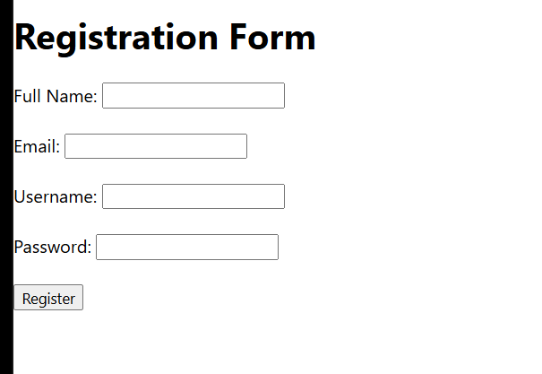

3. Choose the proper semantic element for navigation and justify its usage.
Correct Answer: B. <nav>
The correct semantic HTML element for a website's navigation menu is the <nav> element.
The correct code can be written as:
<nav>
<a href="index.html">Home</a>
<a href="about.html">About</a>
<a href="services.html">Services</a>
<a href="contact.html">Contact</a>
</nav>
The <nav> element is a semantic HTML5 element specifically intended to contain a set of important navigation links. It clearly communicates the purpose of the content to browsers, search engines, developers, and assistive technologies.
Using semantic HTML improves the structure and meaning of a web page. For example, screen readers can identify the <nav> element as a navigation region, making it easier for users with accessibility needs to navigate the website.
The <nav> element also makes the HTML code easier to understand and maintain. A developer can immediately recognize that the content inside the element represents website navigation.
Explanation of Other Options:
Option A: <div>
The <div> element is a generic container. It does not provide any specific semantic meaning. Although it can technically be used to contain navigation links, <nav> is more appropriate because it clearly identifies the content as navigation.
Option C: <section>
The <section> element represents a thematic grouping of content. It is not specifically intended for navigation menus.
Option D: <header>
The <header> element represents introductory content or a header for a page or section. A navigation menu may sometimes appear inside a <header>, but <header> itself is not specifically intended to represent navigation.
Conclusion:
Therefore, Option B, <nav>, is the correct answer because it is the standard semantic HTML5 element for defining navigation links. It improves accessibility, readability, maintainability, and the semantic structure of the web page.

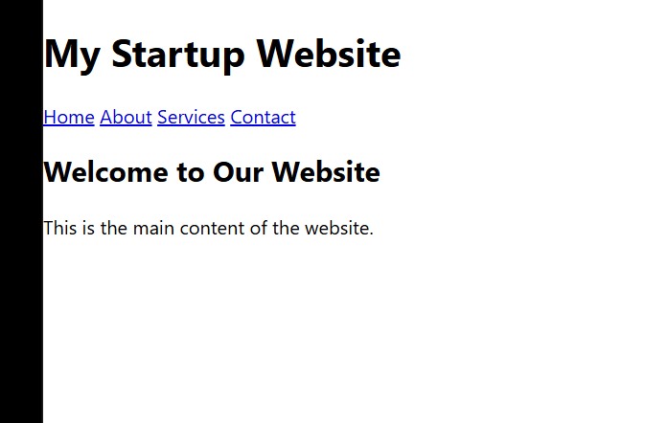

4. Identify the correct XML syntax and explain the error in other options.
Correct Answer: B. <note><to>User</to><from>Admin</from></note>
The correct XML syntax is:
<note>
<to>User</to>
<from>Admin</from>
</note>
This is a valid and well-formed XML structure.
XML stands for Extensible Markup Language. It is commonly used for storing, organizing, and transferring structured data. XML has strict syntax rules that must be followed.
In Option B:
- The <note> element is opened using <note>.
- The <to> element is opened and correctly closed using </to>.
- The <from> element is opened and correctly closed using </from>.
- The <note> element is finally closed using </note>.
- All elements are properly nested.
- Every opening tag has a matching closing tag.
Therefore, Option B follows the rules of well-formed XML.
Explanation of Option A:
<note><to>User</to><from>Admin</from>
This option is incorrect because the <note> element is opened but is never closed.
The correct structure should end with:
</note>
Therefore, the missing closing tag makes the XML document not well-formed.

Explanation of Option C:
<note><to>User</from></note>
This option is incorrect because the opening <to> tag is closed using </from>.
XML requires the opening and closing tags of an element to have the same name.
The correct structure should be:
<to>User</to>
The tags are mismatched in Option C, so the XML syntax is invalid.

Explanation of Option D:
<note to="User"></note
This option is incorrect because the closing tag is incomplete. The closing > symbol is missing from the </note> tag.
The correct syntax is:
<note to="User"></note>
The opening tag also contains a valid attribute named to with the value "User". However, the original option is invalid because the closing tag does not contain the required > character.
Conclusion:
Therefore, Option B is the correct XML syntax because all elements are properly opened, closed, and nested. XML requires strict adherence to syntax rules, including matching opening and closing tags and proper nesting.

5. Choose the correct protocol for web communication and justify your choice.
Correct Answer: B. HTTP
The correct protocol for communication between a web browser and a web server is HTTP, which stands for HyperText Transfer Protocol.
HTTP is the fundamental application-layer protocol used to transfer web resources between clients and servers. When a user enters a website address into a browser, the browser sends an HTTP request to the web server. The server processes the request and sends an HTTP response back to the browser.
The communication process can be represented as:
Web Browser → HTTP Request → Web Server → HTTP Response → Web Browser
For example, when a user requests a web page, the browser may send an HTTP GET request. The server then responds with the requested HTML document and other resources.
In modern web applications, HTTPS (HyperText Transfer Protocol Secure) should be used instead of plain HTTP when secure communication is required. HTTPS uses encryption through TLS to protect data exchanged between the browser and server.
This is particularly important for the startup's registration system because user information, such as passwords and personal details, should be protected while being transmitted over the Internet.
Explanation of Other Options:
Option A: FTP (File Transfer Protocol)
FTP is primarily used for transferring files between computers over a network. It is not the standard protocol used for normal communication between web browsers and web servers.
Option C: SMTP (Simple Mail Transfer Protocol)
SMTP is primarily used for sending email messages between mail servers and email clients. It is not used for normal web page communication.
Option D: SNMP (Simple Network Management Protocol)
SNMP is used for monitoring and managing network devices such as routers, switches, and servers. It is not the standard protocol for communication between web browsers and web servers.
Conclusion:
Therefore, HTTP is the correct answer because it is the standard protocol used for communication between web browsers and web servers. However, for a modern application that handles user registration and sensitive information, HTTPS should be used because it provides encrypted and secure communication.

Final Answers Summary
Question | Correct Option | Correct Answer
1 | B | <video src="video.mp4" controls></video>
2 | B | POST
3 | B | <nav>
4 | B | <note><to>User</to><from>Admin</from></note>
5 | B | HTTP

Web Browser
|
| HTTP Request
| GET /index.html
v
Web Server
|
| HTTP Response
| 200 OK
| HTML Page
v
Web Browser
|
| Renders
v
Web Page
Overall Conclusion
The startup should follow standard web development practices to build a reliable and modern web application. The <video> element should be used to embed promotional videos, while the POST method should be used to submit registration data. The <nav> element should be used for semantic navigation menus because it provides meaningful structure and improves accessibility. XML configuration files must follow strict syntax rules, including properly matched and nested tags. Finally, HTTP is the standard protocol for web communication, while HTTPS should be used when secure communication and protection of user data are required. Following these standards helps improve the application's functionality, security, accessibility, and maintainability.

Code of Conduct:
I G Venkatesh Reddy/192372262 certify that this submission is my
original work and that I have adhered to the guidelines specified for this assessment.
I understand that any violation of academic integrity rules will result in disciplinary
action.
Signature of the student:
G Venkatesh

